WESTSIDE KOINONIA FORTH DAY PARTNERSHIP FUND
AUTHORIZATION AGREEMENT FOR DIRECT PAYMENTS (ACH Debits)

I ________________________________________________hereby authorize William E. Pappas CPA Inc. 30980 Lorain Road North Olmsted, Ohio to initiate debit entries to my checking account indicated below at the depository financial institution named here below, hereafter called “DEPOSITORY”, and to debit the same to such account. I acknowledge that the origination of ACH transactions to my account must comply with the provisions of the U.S. law.
Effective Date:___________________ and each month thereafter for the duration of agreement
Depository Name: __________________________________________________________________
Routing Number: ___________________________________________________________________
Account Number: ___________________________________________________________________
AMOUNT EACH MONTH $__________________
I acknowledge that the amount indicated above shall be a monthly ACH debited to my account effective on the 5th each month beginning __________________________.
This authorization is to remain in full force and effective until WILLIAM E. PAPPAS CPA INC. has received written notification from me of its termination in such time and in such manner as to afford WILLIAM E. PAPPAS CPA INC. and DEPOSITORY a reasonable opportunity to act on it.
NAME________________________________________________________
DATE_________________________________________________________

SIGNATURE____________________________________________________

I would like my Partnership listed as:
NAME__________________________________________________
IN MEMORY OF__________________________________________
NOT LISTED
INSTRUCTIONS ON BACK
AUTHORIZATION AGREEMENT FOR DIRECT PAYMENTS (ACH Debits)
INSTRUCTIONS
BE SURE TO FILL IN ALL BLANK
USE ROUTING AND ACCOUNT NUMBER FROM A CURRENT CHECK AND NOT A DEPOSIT SLIP (they are different numbers)
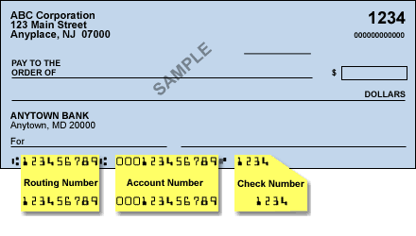
SIGN AND DATE FORM
FILL OUT HOW YOU WANT YOUR PARTNERSHIP LISTED
Personal
In memory of
Corporate
Anonymous
SEND COMPLETED FORM TO:
WILLIAN E. PAPPAS CPA INC.
30980 Lorain Road
North Olmsted, OHIO 44070
WESTSIDE KOINONIA IS A 501c3 NON-PROFIT CHARITABLE CORPORATION. ALL DONATIONS ARE TAX DEDUCTABLE.

